**A Project Report on**

***Learning a Deep Convolutional Network***

***for Image Super Resolution***

**Submitted by**

N. Sreekanth (R171165),

P. Dharani pathi (R170584),

S. Abdul Sharif (R170986),

T. Praveen Kumar (R171134)



Under the supervision of

MR. P. Harinadha

Assistant Professor ,Head of the Department of CSE in RGUKT , RKValley

As a part of Mini-Project in E3-SEM2.

**Acknowledgement**

We would like to express our sincere gratitude to Mr.P Harinadha Sir , our project internal guide for valuable suggestions and keen interest throughout the progress of our course of research .

We are grateful to Mr. Harinadha HOD CSE, for providing excellent computing facilities and congenial atmosphere for progressing with our project .

With Sincere Regards,

N. Sreekanth (R171165)

P. Dharanipathi (R170584)

S. Abdul Sharif (R170986)

T. Praveen Kumar (R171134)

CERTIFICATE



This is to certify that the report entitled “ Learning a Deep Convolutional Network for Image Super Resolution” Submitted by N. Sreekanth , P. Dharanipathi , S. Abdul Sharif , T.Praveen Kumar in partial fulfillment of the requirement for the award of Bachelor of Technology in Computer Science Engineering is a bonafide work carried out by her under supervision and guidance.

The report hasn’t been submitted previously in part or in full to this or any other university or institution for the award of any degree. Under the Guidance of Mr.Harinadha (Assistant Professor , HOD of Computer Science &Engineering, RGUKT, R.K Valley).

**Declaration**

We P. Dharanipathi , T. Praveen Kumar , N. Sreekanth ,S. Abdul Sharif here by declare that this report entitled “Triple Ride Detection” submitted by me under the guidance and supervision of Mr.Harinadha , is a bonafide work. I also declare that it has not been submitted previously in part or in full to this university or other university or institution for the award of any degree or diploma.

Date: 19-09-2022 ID NO:

Place: RK Valley P. Dharanipathi (R170584),

N. Sreekanth (R171165),

T. Praveen Kumar (R171134),

S. Abdul Sharif (R170986).

**Abstract**

The study of Plant Diseases refers to the studies of visually observable patterns of a particular plant. Nowadays crops face many diseases. This paper provides a method to detect disease by calculating leaf area through pixel number statistics. The method studied is for increasing throughput and reducing subjectiveness arising from human experts in detecting the leaf disease. Leaf spots can be indicative of crop diseases, where leaf batches are examined manually and subjected to expert opinion. In this paper an Image Processing system is developed to automate the inspection of these leaf spots.

**Introduction**

India is an agricultural country; wherein about 70% of population depends on agriculture. However, the cultivation of these crops for optimum yields and quality produce is highly technical. It can be improved by aid of technological support. The management of plants requires close monitoring especially for the management of disease that can affect production significantly and subsequently the post harvest life. The naked eye observation of experts is the main approach adopted in practice for detection of plant diseases. However this requires continuous monitoring of experts which might be prohibitively expensive in large farms. Automatic detection of plant diseases is an essential research topic as it may prove benefits in monitoring large fields of crops and thus automatically detect the symptoms of diseases as soon as they appear on plant leaves. Therefore looking for fast, automatic, less expensive and accurate method to detect disease by calculating leaf area through pixel number statistics.

**The image processing can be used in agricultural applications for following purposes:**

1. To detect diseased leaf, stem, fruit
2. To quantify affected area by disease.
3. To find shape of affected area.
4. To determine colour of affected area.
5. To determine size & shape of fruits.

**Purpose**

Many an image processing approaches has been developed in recent years. The purpose of plant leaf disease detection , i.e. detecting the growth of a disease at an early stage, determining the type of the disease the leaf is infected with and suggesting necessary actions.

The purpose of image processing is divided into 5 groups. They are:

1. Visualization - Observe the objects that are not visible.

2. Image sharpening and restoration - To create a better image.

3. Image retrieval - Seek for the image of interest.

4. Measurement of pattern - Measures various objects in an image.

5. Image Recognition - Distinguish the objects in an image.

**Dataset Collection**

Actually we are working on **Citrus** leave diseases. So we selected some diseases to work.

These are the diseases:

* Black Spot
* Canker
* Greening
* Powdery Mildew
* Psylla

**Indications of Citrus Diseases**

|  |  |
| --- | --- |
| **Illness of Citrus Disease** | **Indications** |
| Black Spot | Reddish-brown markings formed on the leaves irregularly |
| Canker | Water-Soaked yellow halo boundaries |
| Greening | Yellow Spots |
| Psylla | Twisted leaves, ant activity |
| Powdery Mildew | White powdery bacteria sometimes form on the upper side |

**Dataset Specifications**

|  |  |  |
| --- | --- | --- |
| **Plant** | **Disease name** | **No. of Images** |
| **Citrus** | Black spot | 340 |
| Canker | 366 |
| Greening | 360 |
| Powdery Mildew | 337 |
| Psylla | 650 |
| **Total : 2053** | |

**Sample Images of Black Spot**

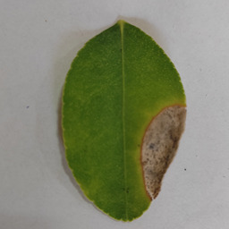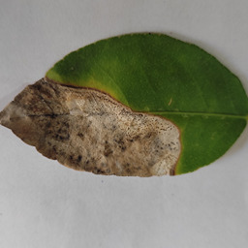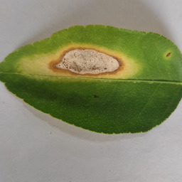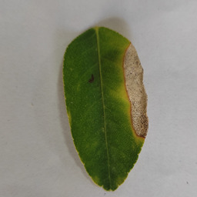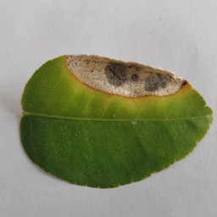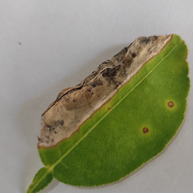

**Samples images of Canker**

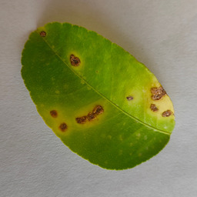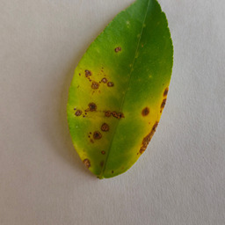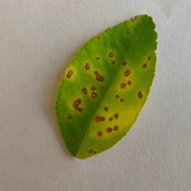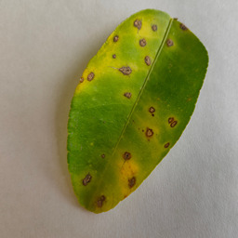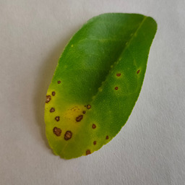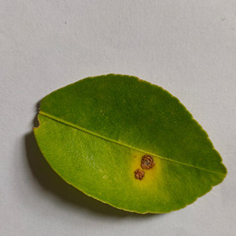

**Samples images of Greening**

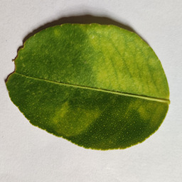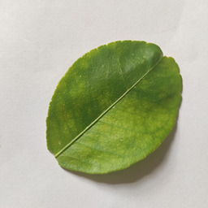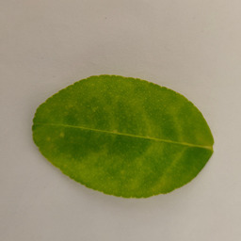

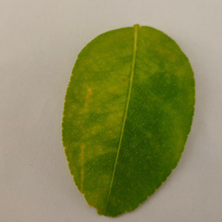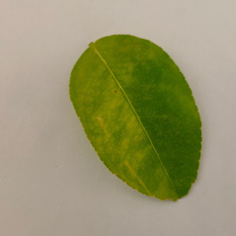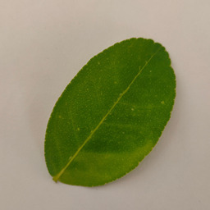

**Samples images of Powdery mildew**

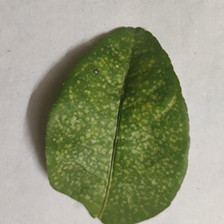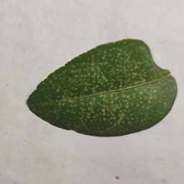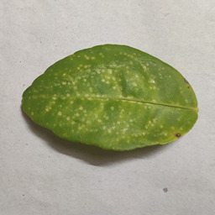

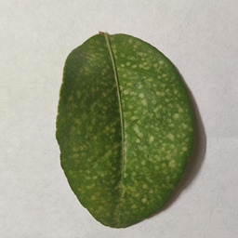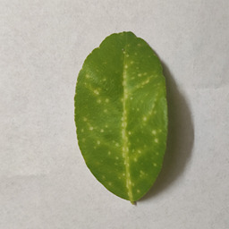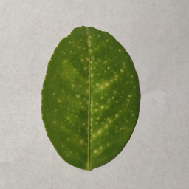

**Sample images of Psylla**

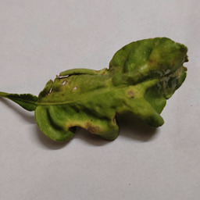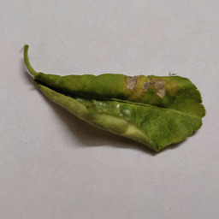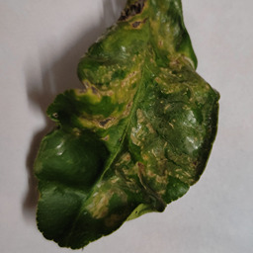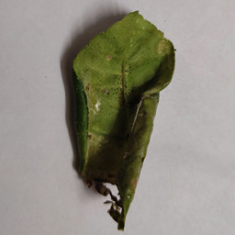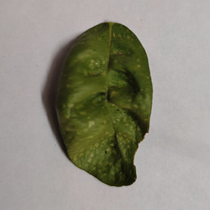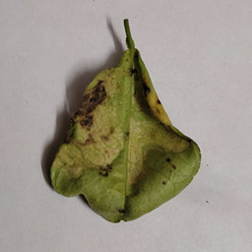

**Flowchart**

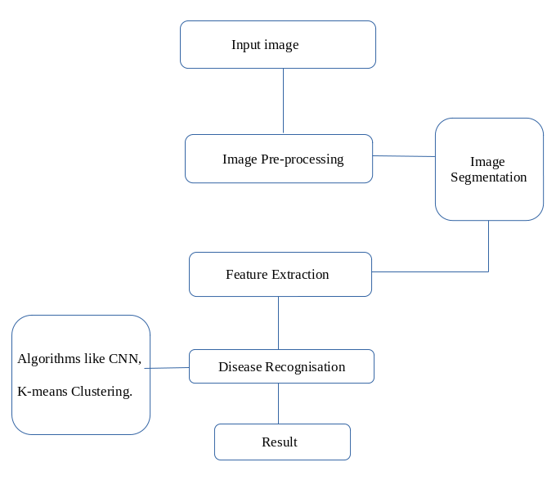

**Methodology**

**Input image:**

We used digital leaf images to identify diseases. There are five citrus leaf diseases that we used in this research, namely Black spot , Canker, Greening, powdery mildew, Psylla. These diseased images are in JPG format.

**Image preprocessing:**

Image pre-process tasks are the initial stage before feature extraction. There are three steps of image preprocessing processing, i.e., image cropping, image converting and image enhancement. The image is cropped on leaf diseases area, and then converted to gray levels. To enhance the image we used Laplacian filter.

**Image Segmentation:**

Image segmentation is one of the most important precursors for disease detection and has a crucial impact on the overall performance of the developed systems. The K-Means clustering technique is a well-known approach that has been applied to solve low-level image segmentation tasks. This clustering algorithm is convergent and its aim is to optimize the partitioning decisions based on a user-defined initial set of clusters .Paper proposed k-means segmentation method to segment target areas. The area affected by the disease is the target area.

**Feature Extraction:**

Proposed method include two features color texture and space features. These features are total 17 in numbers including 13 color features and 4 shape features. Shape features including area, perimeter, circularity and complexity were extracted from the binary segmentation images. Color features and texture features were extracted from the color segmentation image. The image analysis technique is done using Color Co-occurrence Matrix (CCM).

**Advantages**

* It generates high accuracy results
* It saves time
* It produces efficient results.
* It enhances plant productivity
* Images can be smoothened.
* Images can be given more sharpness and better visual appearance.

**Disadvantages**

* It's very costly depending on the system used, the number of detectors purchased.
* Time consuming
* Lack of qualified professional

**Conclusion**

The naked eye observation gives poor accuracy, & it is subjective which will vary person to person. Hence image processing method is used to obtain high precision & accuracy whether leaf with the maximum dimensions. It will consume less time compare to any manual interfere as well as it can be easy to process if images are stored. This algorithm will help to detect amount of disease present on the leaf, by means of presence of holes & changes in the color. It will be easy to go for the severity measurement of disease.